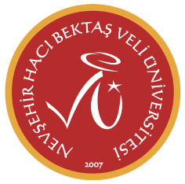
CERTIFICATE OF ATTENDANCE

Date:

Dear Colleague,

We kindly ask you to complete this form for educational activities (seminars, lectures etc.)/study visit of following staff, while he/she is visiting your institution.

Thank you very much for your collaboration.

Warm regards.
Nevsehir Hacı Bektas Veli University
International Relations Office

Name of the staff:

Faculty/Department/School:

Date of Arrival:

Date of Departure:

Signature of Nevsehir Hacı Bektaş Veli University Staff:

Name and Signature of Erasmus Coordinator of the Host Institution:

University Seal/Stamp:

Activities :
Study visit to organize the future mobility.
Monitoring visit
Training undergraduate level ……. hrs.(min 5 hrs/week).
graduate level
general

Teaching/Tutoring undergraduate level ……. hrs.(min 5 hrs/week).
graduate level

Meeting with Nevsehir Hacı Bektaş Veli University Students/Teachers

