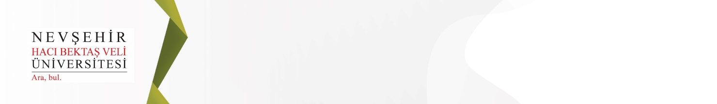

Kapadokya Eğitim Dergisi

Cappadocia Journal of Education

E-ISSN: 2717-9346
DECLARATION FORM THAT NO ETHICS COMMITTEE PERMISSION IS REQUIRED
TO THE EDITOR OF THE CAPPADOCIA JOURNAL OF EDUCATION

As the responsible author, I declare that I have informed the other authors about the completion of this document; I didn’t collected data from the participants by using any questionnaire, interview, focus group work, observation, experiment, or other interview techniques; I didn’t do experiments on humans and animals, etc.; I didn’t violated personal data protection law, and this study does not require any ethical committee approval.
Title
Field of Study
Abstract
Keywords
Authors
 | University/Institution | Name Surname
1
2
3
4
5

Corresponding Author
University/Institution
Address
E-mail
Mobile Phone Number
Signature

NOTE: Please fill out the form, print, sign, scan and upload it to the DergiPark as pdf. It is sufficient for only the corresponding author to sign the form, provided that the other authors are informed.

